VENUE: Italia Conti Woking
Website: Woking | Italia Conti
Address:
Italia Conti
2 Henry Plaza
Victoria Way
Woking
Surrey, GU21 6BU
What Three Words: DEFLECTION.SORRY.LAUNCH

Location on Google Maps

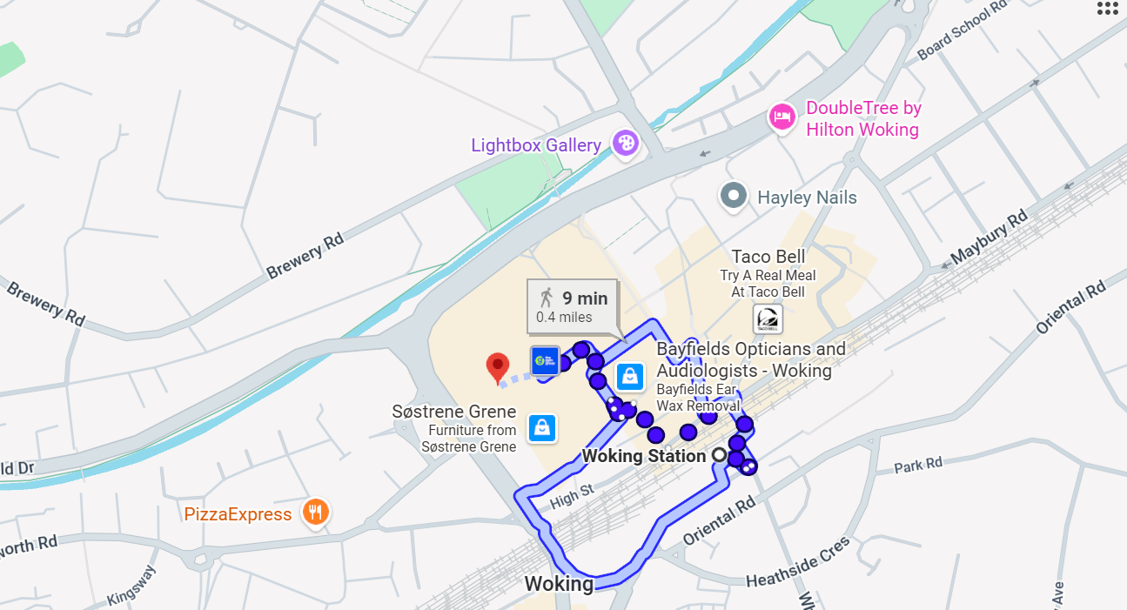

Accessibility information:

Italia Conti is wheelchair accessible with lift access to reach various levels.

During the day, students will visit the Rhoda McGaw Theatre to watch a performance rehearsal. The theatre is a 3-minute walk away from Italia Conti, directions can be found below:

Address:
Rhoda McGaw Theatre
The Ambassadors
Victoria Way
Woking
GU21 6GQ

Location on Google Maps

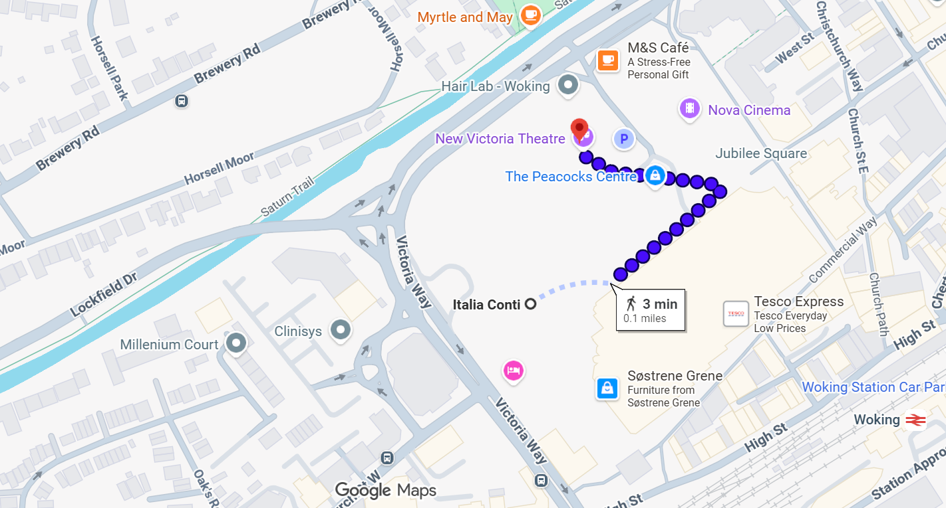

Accessibility information:

The Rhoda McGaw Theatre is wheelchair accessible with lift access to reach the theatre level. There are two wheelchair spaces fixed into the auditorium, and we can reserve more designated space to accommodate additional wheelchair users if required.

Transport & parking information:

Public transport directions: Facilities | Italia Conti

Nearest station – Woking

By Train:

- Woking Station is a 3-minute walk to Italia Conti, 0.3 miles from the site.
- Journey from London Waterloo – 25 minutes
- Journey from Clapham Junction – Roughly 20 minutes

The closest bus stops to the venue are:
- High Street Link Road: Approx. 5 - 6 minute walk
- Goldsworth Road: Approx. 5 minute walk
- Town Quay: Approx. 5–7 minute walk
- Woking Railway Station (Bus Stops 1–5): Approx. 8–10 minute walk

By Coach:

- Located just outside the M5
- Easily accessible by car from the M25, A3 or M4
- Journey time to central London is approx. 1 Hr (traffic dependent)

Regarding coach drop off/pick up, because of the positioning of the building within the shopping centre, it isn't the easiest or most recommended.
There are some small inlets for vehicles to pull into close by at
Hilton Woking, Church St W, Woking GU21 6AX or
Premier Inn Woking Town Centre Hotel. Eurobet House, 10-24 Church St W, Woking GU21 6HT.
However, because these are from other establishments they would not be suitable for coaches to stand waiting for long periods. The shopping centre car park (Victoria Place Shopping Centre) has a max height of 2.1 metres (approx 6 ft 11 in), so also not recommended for larger coaches.

Virtual Tour of building/what to expect: https://youtu.be/iDcG4h2k5dU

Rhoda McGaw Theatre space:

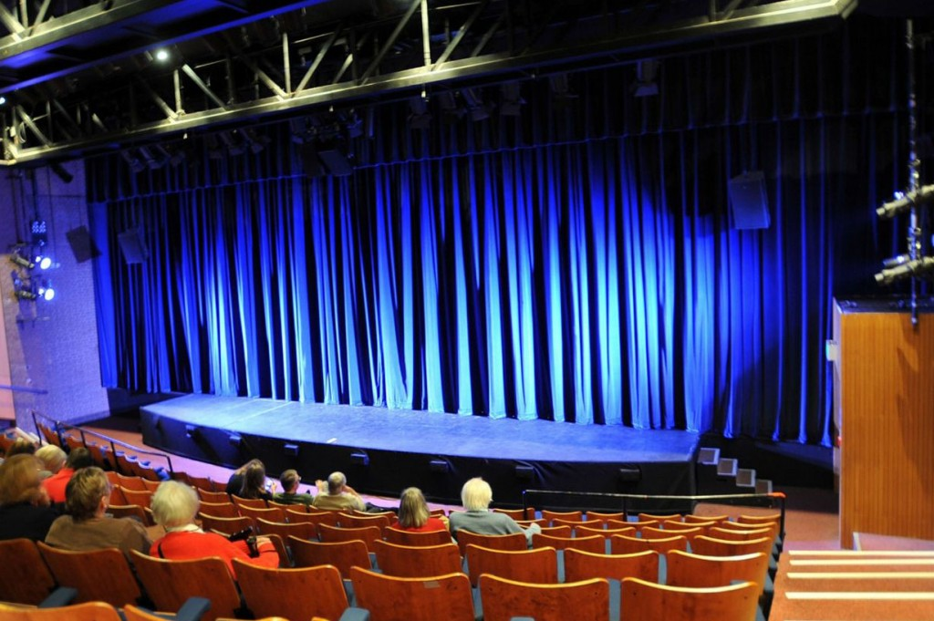

Royal Academy of Dance
188 York Road
London
SW11 3JZ

info@rad.org.uk
+44 (0)20 7326 8000

Royal Academy of Dance is a charity registered in England and Wales No. 312826

ROYAL ACADEMY OF DANCE, RAD, RAD PRE-PRIMARY IN DANCE, RAD PRIMARY IN DANCE and SILVER SWANS are registered trademarks ® of the Royal Academy of Dance. RAD INTERMEDIATE FOUNDATION, RAD INTERMEDIATE, RAD ADVANCED FOUNDATION, RAD ADVANCED 1, RAD ADVANCED 2, RAD CLASS AWARD, RAD SOLO PERFORMANCE AWARD, DANCE TO YOUR OWN TUNE, CBTS and KARSAVINA SYLLABUS are unregistered trademarks™ of the Royal Academy of Dance. The use or misuse of the trademarks or any other content of this publication, without prior written permission from the Royal Academy of Dance is strictly prohibited.

